Christmas Driving Tests – 9th December 2023
Instructions & Regulations v2

Introduction
Welcome to the 2022 Christmas Driving tests. The much-awaited tests once again take place at Stoneleigh Park, Kenilworth, CV8 2LG on Saturday 9th Dec 2023

Entries have been flying in through the online system, if you have entered, please ensure you have paid in advance via the following link here. The PayPal button is at the bottom of the article.

On entering Stoneleigh Park through the main entrance, the test site can be found by turning directly left after the café. The café serves Breakfast, lunch and a good coffee.

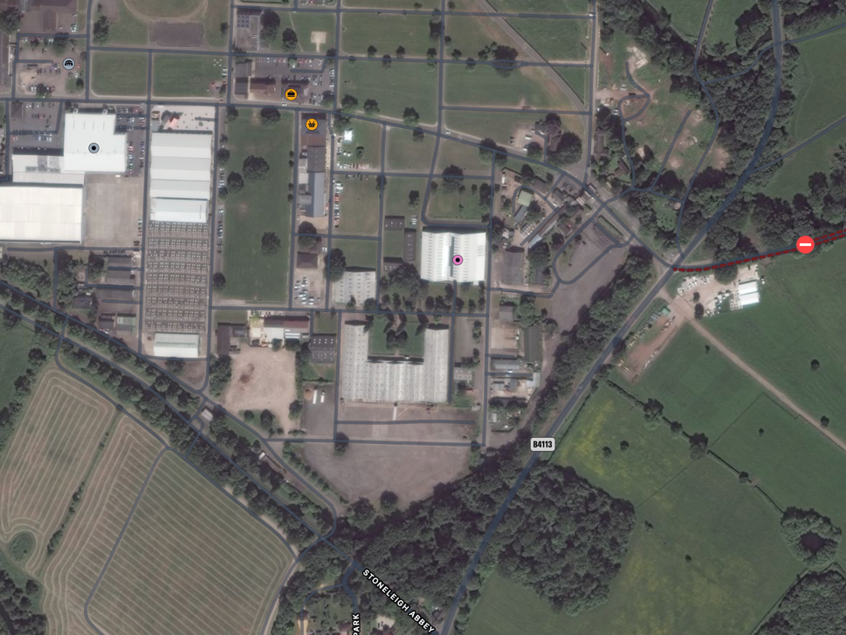
Cafe
Test Site
Main Entrance

Programme
8am | Site and check in opens
8.30am | Scrutineering Commences
9am | Test commence

Documentation
Scrutineering will take place on the day, please ensure you have a copy of your race (or clubman) licence with you.

Supplementary Regulations – MSUK Permit Number 133211

- Event Summary
  - The FNCC will organise a Clubman’s Permit Autotest at Stoneleigh Park, Kenilworth, CV8 2LG on Saturday 9th Dec 2023
  - The event is open to members and friends of the Frazer Nash Car club who hold, at least, a Motorsport UK Clubman licence.
  - Tests will be all-forward with no reversing and can be driven in a standard road car of any type, no modifications required.
  - The meeting will be held under the general Regulations of Motorsport UK Ltd. (incorporating the provision of the international sporting code of the FIA), these supplementary regulations and any written instructions the club may issue for any event.
  - Entries will only be accepted in advance of the meeting. Click Here or copy https://autotest.sapphire-solutions.co.uk/eventlist.php?sitename=frazer to enter.
  - Online entries close at midnight on the 8th Dec.
  - The programme of the meeting is:
    - circuit opens, event administration from 08.00
    - 1st car starts a 09.00.
  - Each driver will complete three tests twice. The total time and any additional penalties will be used to calculate the winner.
  - Scrutineering will be conducted before commencement of the event.
  - The entry fee is £47, or £23.50 for juniors and under 30s. Dual entries are permitted.
  - The maximum entry for the meeting has been limited to 50. The minimum is 20. Should the minimum figure not be reached the organisers have the right to cancel the event. The Club reserves the right to refuse any entry. If more than 50 entries are received a waiting list will be opened.
  - Motorsport UK general regulations apply as written.

- Classes
There will be 2 classes:
Class 1: Pre-war Frazer Nash + GN cars
Class 2: Any other car – any make of model of car is eligible to compete.
Class 3: Juniors. Entries may be accepted from drivers who are aged 16 years and over who do not have a valid licence, subject to the following: (a) The vehicle must by definition be a ‘touring car’;(b) Engine capacity must not exceed 1400cc; (c)Forced induction is not permitted.

Notes to the classes
- Non-Pre-War Frazer Nash or GN cars are not eligible to finish first overall, only within class 2.
- Road going cars do not have to be MOT’d or taxed, however they must be deemed capable of passing an MOT.

- Competitors
  - Competitors must have a full valid RTA licence. Drivers aged 16 and over who do not have a full valid RTA licence my compete in autotests but only in a Touring Car (with a roof and 4 seats) of up to 1400cc.
  - Competitors in the junior classes must be a minimum of 14 years of age and the vehicle must be a Touring Car of no more than 2000cc. They must be accompanied by a passenger with a full valid RTA licence.
  - Passengers may not be carried in classes 1 and 2.
  - All competitors, including passengers, must have as a minimum a Motorsport UK RS Clubman Licence (available at www.motorsportuk.org/competitors/competition-licences).

- Event Officials
Event Steward David Knight
Clerk of the Course Kate Burke (& Secretary of the Meeting - 07855486371 on the day)
Deputy CoC Ben Bayliss
Results Kate Burke
Scrutineer Iain Roche

Judges of Fact shall be all Officials named above, all signed on marshals, plus anyone nominated by the CoC.

- Rules, Penalties, and Results
  - Copies of test diagrams will provided at signing on.
  - Timing will be recorded through TimingAppLive.
  - Competitors will start in their own time, timing will commence as the front wheel passes over the start line. Timing will stop when the front wheel crosses the finish line. Cars must stop before the Stop line or a 10 second penalty will be incurred.
  - The order of attempting tests will be as instructed at drivers briefing.
  - Practising will not be allowed and may result in disqualification.
  - Walking of the course is allowed, but must be complete before the test open at 9.00am.
  - All vehicles must carry a small spill kit, complying with J5.20.13. [M4.6]
  - Penalties will be as follows as per Motorsport UK Yearbook:
    - Pylons, striking any barrier - 5 seconds per offence
    - Lines, failure to stop astride a line as requested – 5 seconds per offence
    - Not performing test correctly – fail. NB fail = fastest time in class, on that test plus 20 seconds.
    - There will be a maximum time for each test which will be fastest time in class plus 20 seconds.
  - In the event of a tie, total penalties accrued by each competitor will be compared after the 1st visit to each test. If this fails to resolve the tie then the total penalties accrued on the 2nd visit will be considered, and so on until the tie is resolved
  - In the event of a tie the fastest run of the first course will determine the tie, then the fastest of the second run, etc, until the tie is resolved.
  - Provisional results will be available throughout the day via TimingAppLive, as will the final results following the end of the event. All appeals must be lodged within 30 minutes of provisional results and any protest must be lodged in accordance with Motorsport UK Regulations C5.1 – 5.7.
  - All queries should be addressed to the Secretary of the Meeting, Kate Burke (kateburke1001@gmail.com)

- Awards
Awards will be presented as follows: -
- 1st Overall - Wentworth Gloucester Tankard (forfeits the Class Awards)
- 1st in Class (if 3 or more starters)
- 2nd in Class (if 5 or more starters)
- 3rd in Class (if 8 or more starters)

WARNING - MOTORSPORT IS DANGEROUS
DESPITE THE ORGANISER TAKING ALL REASONABLE PRECAUTIONS UNAVOIDABLE ACCIDENTS CAN HAPPEN IN RESPECT OF THESE YOU ARE PRESENT AT YOUR OWN RISK

