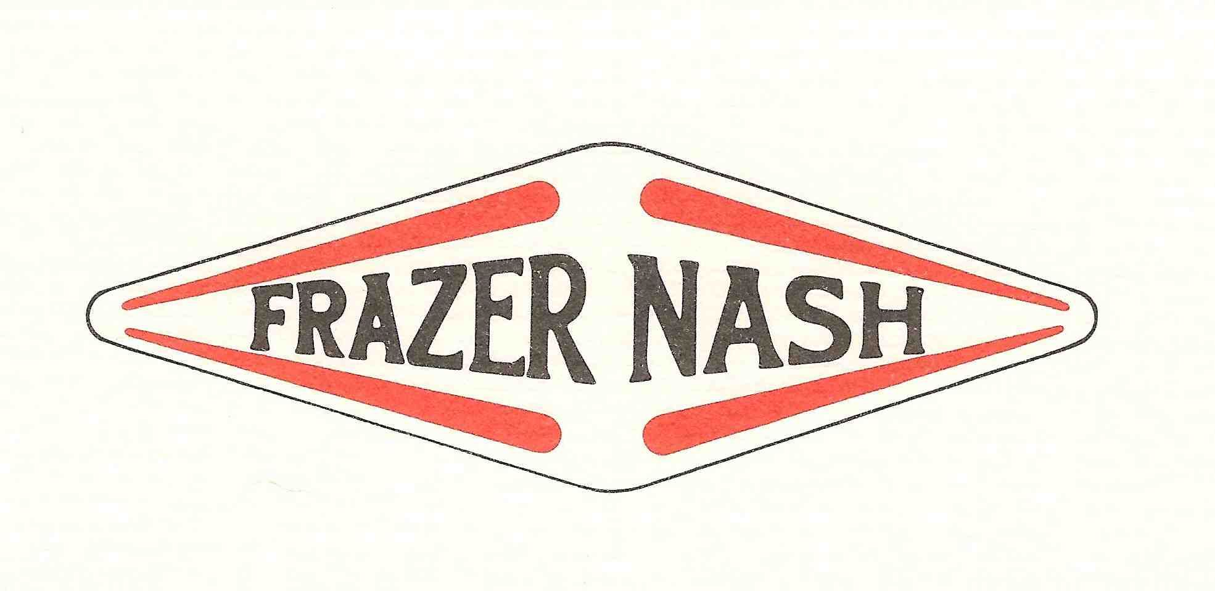

Freddie Giles Memorial Trophy
Castle Combe Autumn Classic 3rd October 2020

Entry Form

Entrant/Driver details:

Entrant’s name _________________________________________________________

Driver’s name (if different from entrant)_______________________________________

MSA Competition Licence number______________

MSA Licence grade International/National A/National B

Address _____________________________________________________

____________________________________________________________

____________________________________________________________

____________________________________________________________

Phone number ___________________ email address ___________________________________

Car details:

Car make _____________________ Car model ____________________ Year __________

Engine make___________________Capacity __________________ Supercharged? Yes/No

In case of injury, please inform ____________________________ relationship___________________

Contact number _________________________________

Signature of entrant ____________________________________________Date __________________

Signature of driver if different to above _____________________________Date ___________________

---------------------------------------------------------------------------------------------------------------------

Method of payment (please indicate which you have used before returning the entry form)

Entry fee £265.00. Half price entry fee if under 30 on April 1st 2020.

- By paypal, via the FNCC website

This completed, signed entry form should be returned by September 11th by email to joanna.waterfield@sky.com or by post to:

Jo Blakeney-Edwards
Hartley House
Westholme Road
Pilton
Shepton Mallet
BA4 4EB

In the event of oversubscription, the organisers will select entrants at their discretion.

---------------------------------------------------------------------------------------------------------------------

FNCC Supplementary regs:

Awards will be presented for 1st overall, 2nd overall & 3rd overall
1st vintage car; 1st sports car; 1st handicap (based on a sealed handicap decided by the organisers)
‘Nashman of the day’

I declare that I have been given the opportunity to read the General Regulations of The Motor Sports Association and, if any, the Supplementary Regulations for this event and agree to be bound by them. I declare that I am physically and mentally fit to take part in the event and I am competent to do so. I acknowledge that I understand the nature and type of the competition and the potential risk inherent with motor sport and agree to accept that risk. I understand that motorsports can be dangerous and accidents causing death, injury, disability and property damage can and do happen. I understand that these risk may give rise to my suffering personal injury or other loss and I acknowledge and accept these risks. In consideration of the acceptance of this entry I agree that neither one or any combination of the MSA and its associated clubs, the organisers, the track owners or other occupiers, the promoters and their respective officers, servants. Representatives and agents (the ‘Parties’) shall have any liability for loss or damage which may be sustained or incurred by me as a result of participation in the event including but not limited to damage to property, economic loss, consequential loss or financial loss however caused. Nothing in this clause is intended to or shall be deemed to exclude or limit liability for death or personal injury. To the fullest extent permitted by law I agree to indemnify and hold harmless each of the Parties in respect of any loss or damage whatsoever and howsoever arising from my participation in this event. I declare that to the best of my belief the driver possesses the standard of competence necessary for an event of the type to which this entry relates and that the vehicle entered is suitable and roadworthy for the event having regard to the course and the speeds which will be reached. I declare that the use of the vehicle hereby entered will be covered by insurance as required by the law which is valid for such part of this event as shall take place on roads as defined by law. If I am the Parent or Guardian of the driver I understand that I shall have the right to be present during any procedure being carried out under the Supplementary Regulations issued for this event and the General Regulations of the MSA. I confirm that I have acquainted myself and the minor with the MSA General Regulations, agree to pay any appropriate charges and fees pursuant to those Regulations (to include any appendices thereto) and hereby agree to be bound by those Regulations and submit myself without reserve to the consequences resulting from those Regulations (and any subsequent alteration thereof). Further, I agree to pay as liquidated damages any fines imposed upon me up to the maxima set out in Part 3, Appendix 1. I understand that should I at any time of this event be suffering from any disability whether permanent or temporary which is likely to affect prejudicially my normal control of my vehicle, I may not take part unless I have declared such disability to the ASN which has, following such declaration, issued a license which permits me to do so. I undertake that at the time of the event to which this entry relates I shall have passed or am exempt from an ASN specified medical examination within the specified period. I have read and fully understood the Procedure for Control of Drugs and Alcohol as contained in the Competitors and Officials Yearbook Regulations H39, D35.1, G15.1.4 and have also fully familiarized myself with the information on the web sites referred to (www. ukad.org.uk and www.wada-ama.org) in particular the UK Anti Doping Rules which have been adopted by the MSA.

CC Autumn Classic supplementary regs to follow.

********************************************************

